Course Name: | Applied Cryptography | Semester: | V
Date of Performance: | 07/10/25 | DIV/ Batch No: | AC2
Student Name: | Aaryan Sharma | Roll No: | 16010123012

Experiment No: 7

Title: Implementation of authentication algorithms

Aim and Objective of the Experiment:
Students should generate Captcha and one of the following authentication mechanisms. Students may use libraries to implement the experiment.
- CAPTCHA Integration: Create a CAPTCHA system to differentiate between human users and bots. Students can generate simple text based or math based captchas.
Use video tutorial: https://www.youtube.com/watch?v=bfKwizfuuOU
- One-Time Pads (OTP): Implement a one-time pad system that generates a series of unique codes for users during login. When executed on two diff systems, the onetime pad sequence has to be the same.
- Challenge-Response Systems: Design a challenge-response mechanism where the server issues a challenge (e.g., a random number or phrase), and the user must respond correctly based on a shared secret key.
- Password-Based Authentication with Salt: Accept password in plain, generate a random salt. Store salt and hash (encrypted password + salt) in the table. When a password is entered, use the same encryption algorithm, use the corresponding salt stored, compute hash function and allow only when there’s a match. Students may use any encryption algorithm.

COs to be achieved:
CO4: Understand Authentication Mechanisms and Evaluate Cryptographic Hash Functions

Books/ Journals/ Websites referred:
- http://www.captcha.net/

Theory:
Need of Authentication
Authentication is the process of verifying the identity of a user, device, or system before granting access to resources. It ensures that only authorized users can access data or perform operations.
Need for authentication:
- To protect sensitive data from unauthorized access.
- To verify the legitimacy of users.
- To maintain system integrity and trust.
- To prevent security breaches and identity theft.
Various Means of Authentication
- Password-based Authentication:
The most common method where users provide a username and password.
Example: Logging into email or social media accounts.
- OTP-based Authentication:
Uses a one-time password sent via SMS or email for verification.
Example: Online banking transactions.
- Biometric Authentication:
Based on unique biological characteristics like fingerprints, facial recognition, or iris scan.
Example: Unlocking smartphones.
- Token-based Authentication:
Uses secure tokens (like JWT) generated after login to access resources.
Example: API authentication.
- CAPTCHA-based Authentication:
Differentiates between humans and bots using text, image, or math puzzles.
Example: CAPTCHA challenges on signup or login pages.

Code:
import random
import string
from PIL import Image, ImageDraw, ImageFont
from IPython.display import display
import time

def generate_text_captcha():
captcha_string = ''.join(random.choices(string.ascii_uppercase + string.digits, k=6))
print("\n=== TEXT CAPTCHA ===")
print("CAPTCHA:", captcha_string)
user_response = input("Enter the CAPTCHA: ")
if user_response == captcha_string:
print("Verification successful!\n")
else:
print("Verification failed!\n")

def generate_math_captcha():
number_one = random.randint(1, 10)
number_two = random.randint(1, 10)
print("\n=== MATH CAPTCHA ===")
print(f"Solve this: {number_one} + {number_two} = ?")
try:
answer_input = int(input("Your answer: "))
if answer_input == number_one + number_two:
print("Verification successful!\n")
else:
print("Incorrect answer. Verification failed!\n")
except ValueError:
print("Please enter a valid number.\n")

def generate_image_captcha():
captcha_content = ''.join(random.choices(string.ascii_uppercase + string.digits, k=5))
image_canvas = Image.new('RGB', (180, 70), color=(255, 255, 255))
image_drawer = ImageDraw.Draw(image_canvas)
try:
font_style = ImageFont.truetype("arial.ttf", 36)
except:
font_style = ImageFont.load_default()
image_drawer.text((20, 15), captcha_content, fill=(0, 0, 0), font=font_style)
for _ in range(8):
x_start, y_start = random.randint(0, 180), random.randint(0, 70)
x_end, y_end = random.randint(0, 180), random.randint(0, 70)
image_drawer.line(((x_start, y_start), (x_end, y_end)), fill=(0, 0, 0), width=1)
print("\n=== IMAGE CAPTCHA ===")
display(image_canvas)
time.sleep(1)
user_response = input("Enter the CAPTCHA text shown above: ")
if user_response.strip().upper() == captcha_content:
print("Verification successful!\n")
else:
print("Verification failed! The correct answer was:", captcha_content, "\n")

def run_captcha_system():
while True:
print("CAPTCHA")
print("1. Text-based CAPTCHA")
print("2. Math-based CAPTCHA")
print("3. Image-based CAPTCHA")
print("4. Exit")
user_selection = input("Enter your choice (1-4): ")
if user_selection == '1':
generate_text_captcha()
elif user_selection == '2':
generate_math_captcha()
elif user_selection == '3':
generate_image_captcha()
elif user_selection == '4':
print("Exiting program. Goodbye!")
break
else:
print("Invalid choice. Please enter 1–4.\n")

run_captcha_system()

Output:
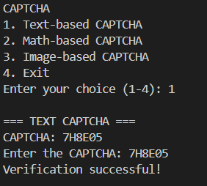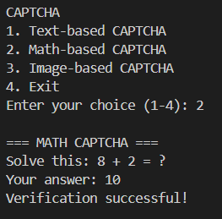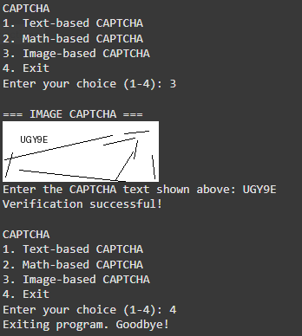

Post Lab Subjective/Objective type Questions:
Compare and contrast various authentication methods for their vulnerabilities and strengths.
1. Password-based Authentication (with salt & hashing)
- Strengths: Simple, widely supported, easy to implement. When combined with a unique salt and a slow cryptographic hash (e.g., bcrypt), it becomes resistant to precomputed attacks and slows brute-force attacks.
- Weaknesses: Vulnerable to weak passwords, phishing, credential stuffing, and server-side breaches if hashing/salting are not implemented properly. Requires good password policies and multi-factor augmentation for strong security.
2. One-Time Passwords (OTP)
- Strengths: Dynamic (single-use), limits usefulness of intercepted credentials, and provides good protection against replay attacks. Can be implemented via time-based OTP.
- Weaknesses: Delivery channels (SMS/email) may be intercepted or socially engineered; hardware tokens can be lost; synchronization/time drift issues for TOTP; implementation complexity for secure provisioning.
3. CAPTCHA (Text/Math/Image)
- Strengths: Effective at distinguishing basic bots from humans, simple to deploy, reduces automated abuse (spam, brute-force login attempts). Image CAPTCHAs and more advanced variants are harder for bots.
- Weaknesses: Usability issues (accessibility), advanced bots/ML can sometimes solve CAPTCHAs, and CAPTCHAs do not authenticate identity, they only assert human interaction.
4. Biometric Authentication (fingerprint, face, iris)
- Strengths: Tied to unique physical traits, convenient (no memorization), hard to share. Good for device-local authentication and second-factor use.
- Weaknesses: Privacy concerns, non-revocability (you cannot change your fingerprint), risk of spoofing if sensors are weak, and requires secure local storage (templates must be protected). False positives/negatives must be carefully managed.
5. Multi-Factor Authentication (MFA)
- Strengths: Combines two or more methods (something you know, have, or are) to drastically improve security and mitigate weaknesses of single factors. Strong protection against credential compromise.
- Weaknesses: Adds user friction and operational overhead; some second factors (SMS) are weaker than others; recovery flows must be secure to avoid account lockout or social-engineering attacks.

Conclusion:
I have successfully completed this experiment. During the experiment I implemented and tested three CAPTCHA types (text, math, and image). I also evaluated strengths and weaknesses of common methods and learned best practices for secure implementation. This experiment improved my practical understanding of authentication design and the trade-offs between usability and security.

